**Embedded walking stick and bus identification system for the visually impaired**

1. **Abstract:**

* Through numerous studies, the need for an accessible urban transportation system for visually impaired has been firmly established. However, most public transportation systems in developing countries are not accessible to the visually impaired forming a major bottleneck for their social and economic inclusion. The project utilizes a radio-frequency based, solely user-triggered system that helps the user to first identify the route number and then enables the user to board the bus using auditory cues from the entrance of bus.
* To further facilitate movement of visually impaired, the bus identification module is integrated with an embedded walking stick consisting of various sensors for navigation and obstacle detection. Several design improvements were done after discussing a quantitative evaluation of real-life field testing.

1. **Background:**

* In the past there have been similar research efforts to develop embedded devices to alleviate problems. The Talking Signs identification system consists of infrared (IR) transmitters incorporated in the destination panels of buses that transmit route information. Since, an IR beam is highly directional, the visually impaired user must point the handheld receiver towards the transmitter on the bus which is difficult since the precise bus location is unknown.
* In the PAVIP Public Traffic system, RFID transponder tags are placed on bus stops that transmit information about the route numbers of buses approaching. However, the system does not give the user an active choice to select between multiple buses that may be present at the bus stop and the problem of boarding the bus remains unresolved.
* Step-Hear, a RF based system comprises of a transmitter and a small activator. The system does not provide any means for the user to choose between different transmitters and does not handle the case of multiple activators and transmitters within range of each other.
* Broadcasting bus is a GPS based system announcing the bus number upon arrival at the bus terminal. A pilot survey showed that the smart bus stops are not adequate when equipped only with the voice reporting system because voice information is difficult to decipher when many buses simultaneously arrive at the same terminal.
* A study carried out at university college of Ireland explored issues concerning access to public transport for people with sight loss. The study conveyed that providing audible announcement at different stages of boarding, actually improves their access to public transport. But, this research does not focus on how a visually impaired could independently identify and board his/her desired bus of interest. Moreover, there was no such mechanism that could guide a VI person in identifying the entrance door of the public transport especially when buses stop in a wide range at a bus stop.
* All the systems that have been proposed have one or more of the following limitations:
  + No GPS connectivity in buses of developing countries
  + Non-availability of sales, marketing or servicing in developing countries
  + Unaffordable cost
  + Inability to board a desired bus, since multiple buses arrive and line up arbitrarily at random positions at bus stops
  + Dependence on electricity or structural support that is not available at most of the bus stops
  + Route number display on the front top panel of the bus, makes it difficult for a blind person to identify since there are no audio cues
  + Dependency of a visually impaired person on fellow travelers.
* To the best of my knowledge, there is no such affordable and user validated system which provides the auditory cues from the bus, helping them in identifying his/her bus of interest before the bus approaches the bus stop. Further the process of identifying the entry door of the bus is integral part of the system. This system is so designed to address the above limitations in addition to meeting the specific requirement of public bus service providers. Study of challenges faced by visually impaired in accessing public buses and design and user testing of an affordable bus identification system had already been addressed.

1. **Objective:**

* To enable visually impaired people to board his or her required buses independently through RFID based bus identification and boarding system.
* To facilitate a visually impaired person in path navigation assistance and obstacle detection through an embedded walking stick.

1. **System design & subsequent modifications for installation**

* **System description:**

The system comprises of two modules: (i) User Module and (ii) Bus module. Once the user hears a bus approaching the bus stop, he presses the Query Button on the User Module, transmitting a RF signal to all buses in the vicinity. Each bus responds to the User Module by transmitting its route number. All numbers received are sequentially read out by the user module. User may proceed to select the desired route number by pressing the Selection Button which triggers a voice output from a speaker located at the entry of the selected bus. This acts as an auditory cue and assists in moving towards the entry door of the bus. The system allows for flexibility to customize operation according to user specific bus usage patterns, saving time and effort. Using an auditory interface, the user can store the route numbers of commonly boarded buses (called a restricted set) in the user module. This allows the user to concentrate only on relevant bus numbers.

• Auto-Query mode (optional): The device automatically scans for buses at regular intervals and notifies the user. This eliminates the user’s need to continuously press the query button.

• Pre-selection mode/Restricted set: In case the user is interested in boarding one particular bus, he or she can store its route number in advance and use the selection button to check if the desired bus is present at the bus stop. This allows the user to skip the query phase and immediately check for the desired bus.

A number feeding unit was developed to program / change the route number of a particular bus module (with a unique id) as and when required. This operation can be done remotely within a range of 30m without the necessity of having a physical wired connection.

* **Design improvements and modifications for installation:**

In this section, we detail the modifications that reduced the maintenance cost, improved the system efficiency and made it more robust. The goal of the modifications was to maximize usability with minimal changes to the permanent infrastructure of buses and bus agency support structure. The bus module required design modifications and customizations in order to allow installation in varying buses being used by different organizations we have dealt with. In this phase of trials, we ensured no modifications to the existing bus infrastructure was required. The overall design of the bus module is divided into two parts: (i) Speaker and Antenna module installed on the railings of the bus, and (ii) Under-the-Seat Module comprising of the battery, amplifier and control circuits. The long wire antenna connectors enable installation of the antenna at a suitable place (top of the speaker box) for better communication.

For easy maintenance and timely indication of system failures, a LED grid has been incorporated to indicate successful charging in progress, sufficient battery power and a healthy functional system. The environmental noise is observed to be very high in some cities compared to others. Thus, there was a need to keep the volume of the loudspeakers adjustable. A variable potentiometer has been provided so that the sound level can be adjusted manually. Our previous version of the bus module weighed almost 8 kg, thereby, making the deployment of the system difficult, leading to difficulty in maintenance. The current speaker module which hangs on the window railings only weighs 2 kg and the under-the-seat module weighs 3.5 kg. Further, the modules are much more robust considering that they are fabricated on a single printed circuit board, while the various circuits have been embedded.

The charging mechanism in the previous version of bus module comprised of a transformer and a rectifier, which made the system bulkier. In the new bus module, the charging port has been integrated along with the other circuitry and is shifted to the exterior of the box. This has eliminated the need of the transformer and the rectifier, thereby easing the charging. Additionally, a relay has been added to bring down the power usage when the device is in sleep mode. The improvement has brought down the charging requirement from 1 day to 7 days.

1. **Working methodology:**

The bus identification device works on radio frequency interrogative device (RFID) technology. The three groups are as follows:

1. The first group is that of blind persons who are equipped with a blind stick to which a transmitter circuit is attached.
2. The second group consists of buses arriving and departing from the bus stand. The buses are also equipped with a transmitter circuit enabling the driver of the bus to notify his bus number to the bus stand.
3. The third group consists of bus stands equipped with a receiver circuit(passive). The receiver circuit is capable of receiving transmissions from both the blind person and the buses.

The Blind Stick of the blind person is installed with a radio frequency transmitter system (passive type), which is used by the blind person to communicate with the bus stands and send his/her request for a specific bus route number. According to this request, the transmitter is capable of sending a serial code with specific frequency. The transmitter system does this with the help of one microcontroller (89S51) and an encoder for converting the blind persons request to a serial code. This serial code is received by the RF module receiver at the bus Stand. Thereafter, the decoder IC decodes the serial code and with help of micro-controller, voice processor announces the bus route number/s through speakers installed at the bus stand.

Similarly, the buses arriving at the bus stand are also installed with a radio frequency transmitter system, used by the bus driver to send signal to the bus stand. The transmitter is capable of sending a serial code with specific frequency. The Driver notifies his bus number to the bus stand with the help of this signal. At the bus stand, the request sent by blind person and serial codes sent by the bus drivers, are received by the RF receiver and decoded by decoder IC installed in the receiver circuit at the bus stand, one after another. Microcontroller fitted in the bus stand, with the help of decoder IC, triggers a voice processor to announce the specific bus route number corresponding to the serial code after decoding. After the serial code is decoded, the speaker announces the bus number.

**Block diagram of circuit Block diagram of circuit Block diagram of circuit**

**in the blind stick in the bus at the bus stand**

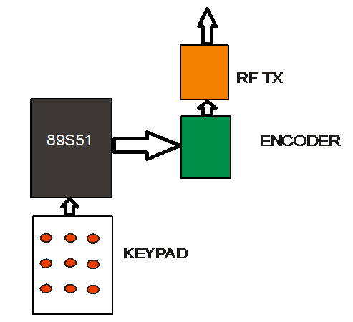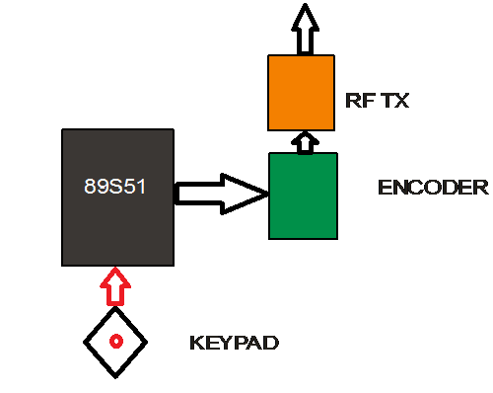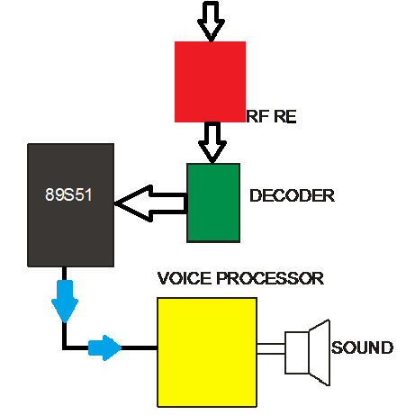

* **Unique features**:

1. The bus stand is also equipped with two lights. Out of these two, one is triggered by the blind stick when the signal is sent by the blind person to the bus stand. The light helps in notifying the presence of a blind person at the bus stand to the bus-driver as well as to co-passengers. The second light glows when the signal from the bus driver (as and when bus reaching the bus stand) is received. Once both the lights glow, it means that a blind person as well as a bus is present at the stand. If the bus is the one required by the blind person, then he gets in with the help of co-passengers and after his requirement is met, he presses the switch in his stick to switch off the light at the stand. Eventually the bus driver also does the same.
2. Through this project, it has been made possible to differentiate between two signals by using passive tags. To do so, we have added a DIP switch to the passive circuits to create different frequencies between the two signals.

* **Embedded walking stick**

This project has converted a normal blind stick into an advanced autonomous electronic blind stick with five different sensors with micro-controller interface. The five sensors are as under:-

1. Interruption sensor;
2. Temperature sensor;
3. Light sensor;
4. Water sensor; and,
5. Vibration motor.

1. This project uses IC 89C51 as a main micro-controller to interface the blind stick with different sensors, voice processors and LEDs. Complete project is divided into following four parts in an 8051 assembler: 5-volt regulated power supply circuit, Sensor interface circuit, Micro- Controller interface, Voice Processor interface.

1.1 This project uses 9-volt battery for the complete circuit. 9 volts is converted to constant 5 volts steady power supply with the help of 7805 regulator. Two capacitors are also connected with the regulator to reduce the ripples generated in the circuit. Output of the regulator is further displayed by the L.E.D. L.E.D is connected with the resistance in series to show a visual indication of the power supply. This 5-volt supply is further connected to the pin no 40 of the controller directly.

1.2 For interruption logic, we use infrared transmitter and photo diode receiver components. The infra-red transmitter continuously sends signals, which gets reflected from the object, returns back to the photodiode. The photodiode senses the signal. The Output of the photodiode is connected to the controller. When stick senses the interruption then voice processor produces a sound installed for the interruption sensor. This sensor will alert the blind person about the incoming vehicle or the object in their path.

1.3 For fire detection or fluctuation in temperature, a thermistor is used for the temperature measurement. There are two type of thermistors available viz, NTC and PTC. In this project NTC thermistor has been used. NTC thermistor changes its resistance as the temperature increases. This property of thermistor is used here for temperature measurement. Thermistor senses the excessive heat and due to heat the resistance of thermistor decreases. This small change of resistance from thermistor is further controlled by the transistor circuit, for which a NPN transistor is connected with the thermistor. When thermistor resistance gets decreased then transistor gets a low positive voltage on the base point. As the transistor base voltage is increased then output L.E.D. starts glowing on. Output from the thermistor is further connected to a microcontroller. Microcontroller triggers the voice processor to produce a sound as per the pre- recorded voice for that sensor.

1.4 As regards light sensor, LDR has been used which is a light dependent resistor. LDR changes its resistance according to the light fall on the LDR. LDR offers a low resistance in light and high resistance in the dark. When more light falls on the LDR, then LDR resistance is decreased. This small change of resistance in LDR is further controlled by the transistor circuit. The transistor with the help of a micro controller and a voice processor, produces a sound from the stick.

1.5 For water sensor simply two conducting wires are used. When these wires come in contact with water then due to completion of circuit automatically it produces sound from the voice processor with the help of micro-controller.

1.6 Using sensory feedback from sensors and directions from google maps, the vibrational motor indicates direction to a visually impaired version by vibrating to the left or to the right.

