**DIGICARE SYSTEM WITH I.V. BAG REPLACEMENT MECHANISM**

**1. OBJECTIVE:**

1. To facilitate poor people and people from villages of remote regions to gain access to health care and monitoring system in a cost-effective manner.
2. To help in achieving self-sufficiency of poor people in diagnosis of various diseases and improve the roles of institutions at various levels in monitoring public health.

**2. FEATURES OF THE PROJECT:**

1. The project enables poor people to check various health related issues/vitals (health parameters such as body temp, heartbeat, breathing rate etc) on their own through a low cost diagnostic device which works on new scientific principles.
2. Many people, living in remote areas, do not have access to doctors/hospitals and cannot go for a regular check-up. The project enables villagers to check the vitals on their own and send the readings to a remote server located in a hospital (or to a doctor) through this device, in case of any abnormality, for further medical advice.
3. The device can be integrated with a mobile phone. In India, there are fewer chances of poor having access to a hospital. However, a villager may possess a mobile phone. This project ensures inclusion of poor people in health-care system with the help of this device together with his mobile phone.
4. **This telemedicine device helps people who receive medication at home and who are prescribed to use glucose or blood (in I.V. bags). This feature helps to trigger an alarm when the fluid level (Glucose/blood in I.V. bags) decreases beyond a certain limit. The system automatically sends the message to the server (here, to a mobile phone number of a nurse or of a family member regarding low level of fluid, reminding with alerts for immediate replacement). It is often observed that nurses are made to attend more patients than they are supposed to attend in hospitals. This is a very useful feature as it can prevent mortality/emergency situations among those patients who are often less attended by nurses. This feature comes integrated with the device.**
5. There is provision for adding additional features also. With this project, ECG sensor can be added to enable the display of the readings of patients’ heartbeats (through electrical signals) in the mobile phone of the user. Simultaneously, the readings can be sent to a server for analysis. The government hospitals may develop an entire new cell to analyse such health reports of people from distant remote villages and give them medical advice. This equipment also helps to update patient’s guardian or a doctor with the patient’s health status. This will improve the roles played by various institutions towards public health and integrate the institutes working in health care sector. The project has wide scope for future.
6. Instant digital outputs of the device including its feedback system is a good motivator for user.

**3. WORKING PRINCIPLE**:

3.1 In this project we monitor and display three different and useful parameters (vitals) related to patient health monitoring system. The concerned parameters are:

1. Heartbeat
2. Body temperature
3. Breathing rate

3.2 The heartbeat sensor uses the principle of a pulse oximeter for measuring patient's pulse rate. A pulse oximeter measures the amount of oxygen in a patient’s blood by sensing the amount of light absorbed by the blood, in blood capillaries under the skin. In the device, a sensing probe is attached to the patient’s finger with a spring-loaded clip or an adhesive band. On one side of the probe is a pair of Light Emitting Diodes (LEDs), and on the other side is a photodiode. One of the LEDs produces red light, and the other produces infrared light. Pulse oximetry depends on the differential optical characteristics of haemoglobin (the blood protein that carries oxygen). When haemoglobin is oxygenated, it becomes transmissive to red light and absorptive to infrared light. However, when haemoglobin contains less oxygen, it becomes relatively more transmissive to infrared light, and more absorptive to red light. By measuring the ratio of red light to infrared light passing through the patient’s finger, the probe can produce a signal proportional to the amount of oxygen in the blood. In addition, the surge of blood on each heartbeat generates a signal representative of the patient’s pulse rate.

3.3 The output of the photodiode is a low amplitude current; thus, some signal conditioning must be applied before it can be used. Operational amplifier is an ideal choice for use in a resistor-feedback transimpedance amplifier configuration. This configuration is also used in other bioelectric sensing applications. The resulting output voltage is read by an analog-to-digital converter(ADC) integrated in microcontroller PIC16F877A.The microcontroller calculates the ratio of red light to infrared light and determines the corresponding oxygen saturation level using a lookup table. This value is then sent via serial communications link to a data acquisition system and displayed for the user. A pulse oximeter is a convenient and easy to use measurement instrument. The information is displayed on a LCD display (16 x 2). The LCD display is capable of displaying a maximum of 32 letters.

3.4 A pulse is essential to the operation of a pulse oximeter and it will not function if there is none. Infrared diode and photodiode are placed inside the tube for better result. As we insert the finger in the tube, then light is passed through the finger and focused on the photodiode. Photodiode resistance changes as per the variation of light on the photodiode. Photodiode is connected to the op-amp amplifier. Here we use LM 324 amplifier IC. Op-amp works as an amplifier circuit. We count the pulses with the help of the PIC16F877A controller, internal timer (counter). The value of number of pulses within 30 seconds is further converted into ASCII code for LCD display. Here, we use alphanumeric LCD to display the total pulse count. If any abnormality is found in heartbeat, then the system requests to send the message to a pre-installed number via the GSM modem.

3.5 For temperature monitoring, we use LM 335 as a temperature sensor. Output of the temperature sensor is further connected to the op-amp circuit. Op-amp circuit amplifies the signal from the temperature sensor and further, sends this signal to the ADC 0804 (analog to digital converter). Output of the ADC is connected to the microcontroller circuit. Microcontroller processes the logic and then the logic is transferred to the LCD driver circuit. LCD displays the current temperature. Current temperature that is displayed on the LCD is analysed and compared with the set value of the controller. When current value is above the set value, then output load or heater is turned off. When the current temperature is less than the set value, then output load is again turned on. Once we set the values of upper and lower limit in microcontroller then, temperature is maintained between two limiting values.

3.6 Steps in temperature detection:

**Step 1**.The temperature signal is amplified by the op-amp circuit.

**Step 2**.Analogue signal is converted to digital signal by using ADC 0804 (integrated in microcontroller PIC16F877A).

**Step 3**.Digital signal is processed by the microcontroller and then converted into ASCII code.

ASCII code is displayed on the LCD by comparing set value and current value.

**Step 4**.Load circuit is eventually turned on by microcontroller.

3.7 Temperature Sensor - The LM335

The LM335 is an integrated circuit sensor that can be used to measure temperature with an electrical output proportional to the temperature (in oC)

The LM335 - An Integrated Circuit Temperature Sensor

Advantages of using LM335

Temperature can be measured more accurately by using a thermistor (here, LM335).

The sensor circuitry is sealed and not subject to oxidation, etc.

The LM335 generates a higher output voltage than thermocouples and may not require that the output voltage to be amplified.

3.8 For breathing rate monitoring, we use a temperature sensor (TMP100). The sensor is installed in a colon. The following steps are used to find the breathing rate:

**Step 1.** As soon as command is given by the user, the breathing sensor is turned on.

**Step 2.** The microcontroller turns on the counter, which is displayed on the LCD display. There is a timer, which is programmed in such a manner that it counts for 30 seconds.

**Step 3.** The temperature reading is taken from the TMP100. If the temperature difference between inspiration temperature and expiration temperature is more than 0.5 degree centigrade, then, it is counted as one breath.

**Step 4.** After 30 seconds, the respiration rate is automatically multiplied by 2 to get the resultant rate.

The resultant rate is displayed on the LCD display.

**Step 5.** The program sequence is stopped after getting the breathing rate.

Note: If any abnormality is found in breathing rate, then the system requests to send the message to installed mobile number via the GSM modem.

3.9 The additional feature of the project is the low glucose/blood detector in I.V. bags. This feature is for those people who are medically supported by fluids (like glucose or blood) at their homes.

For this detection, we use infrared diode and photodiode receiver components. The I.V. bag is attached to a spring, which is fully stretched in the presence of the liquid. As the patient utilizes the liquid and the I.V. bag loses weight, the spring eventually contracts. At a certain point, it interrupts the IR sensor and the photodiode such that photodiode no longer receives the infrared rays. Due to this, an active low signal is created. This signal is sensed by the IC555 at pin no 2. This causes the IC555 to buzz for a particular interval which is further sensed by microcontroller. The microcontroller stimulates the system to send the message to the installed phone number which can be of a nurse or a family member. For glucose detection, the system is made such that the message is sent automatically without the approval of patient. This is done to prevent problems if the patient is not conscious or if he/she is asleep. The circuit diagram is given below:

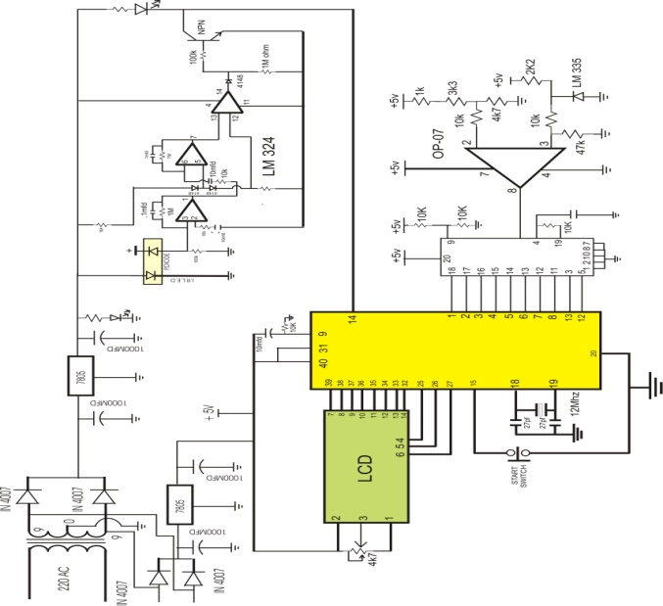

Circuit diagram – 1

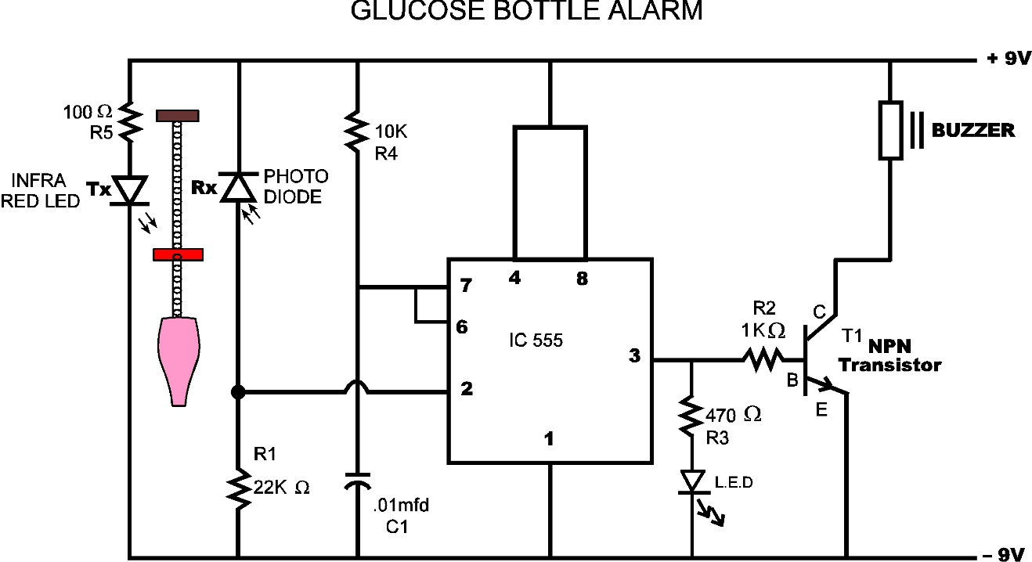

Circuit diagram – 2

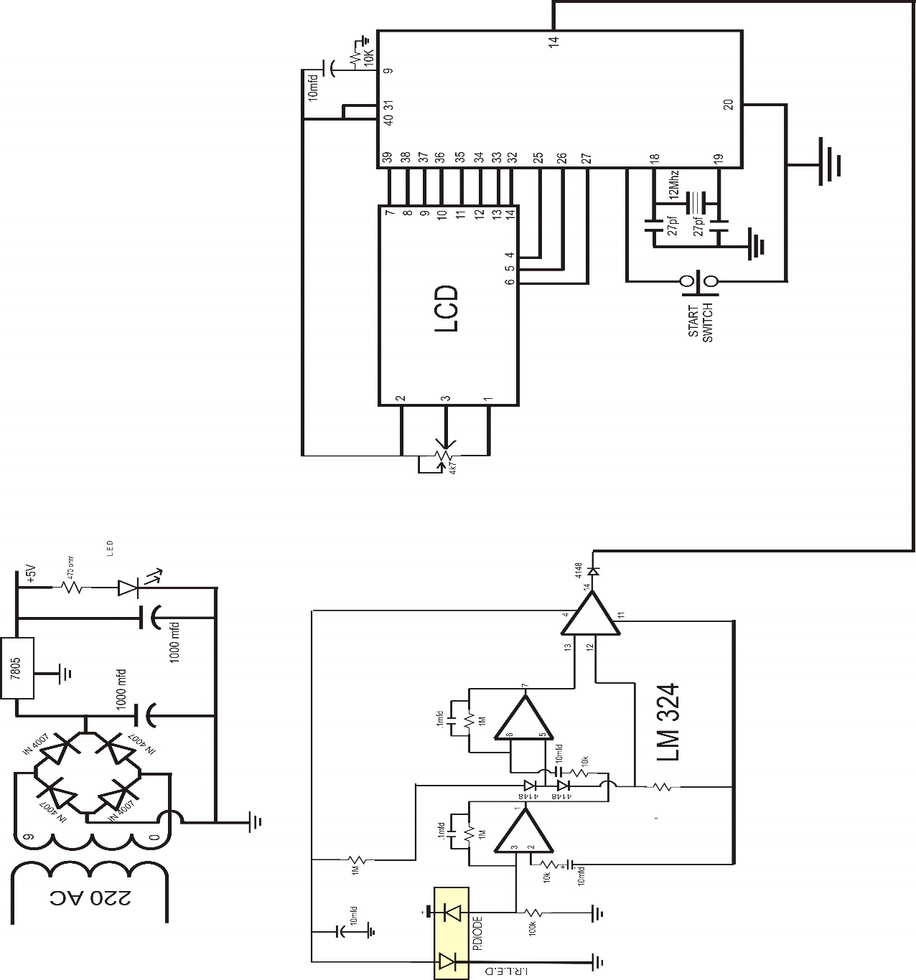

Circuit diagram - 3

4. SCOPE:

In India, we have 6.38 lakh villages. At present, about half of these villages are yet to be covered under organised village health care system of Government of India. India does not have sufficient doctors to man all those villages. Even Para-medical staff are of demand in rural areas.

In India, with help of such devices, Government with its limited available resources, can effectively integrate village health camps (organised periodically & deployed with Para-medical staff) with medical call centres (located at hospitals at district level, run 24x7, managed by certified medical doctors and specialists) under rural health care and monitoring system.

5. COST and TIME: Rs 3500/- and 40days

6. LIMITATIONS:

Generally electronic devices have an error of (+,-) 2 percent. Since our project is a health diagnostic tool, there should be very less scope for errors. Thus, these margins must be considered while analyzing the findings.

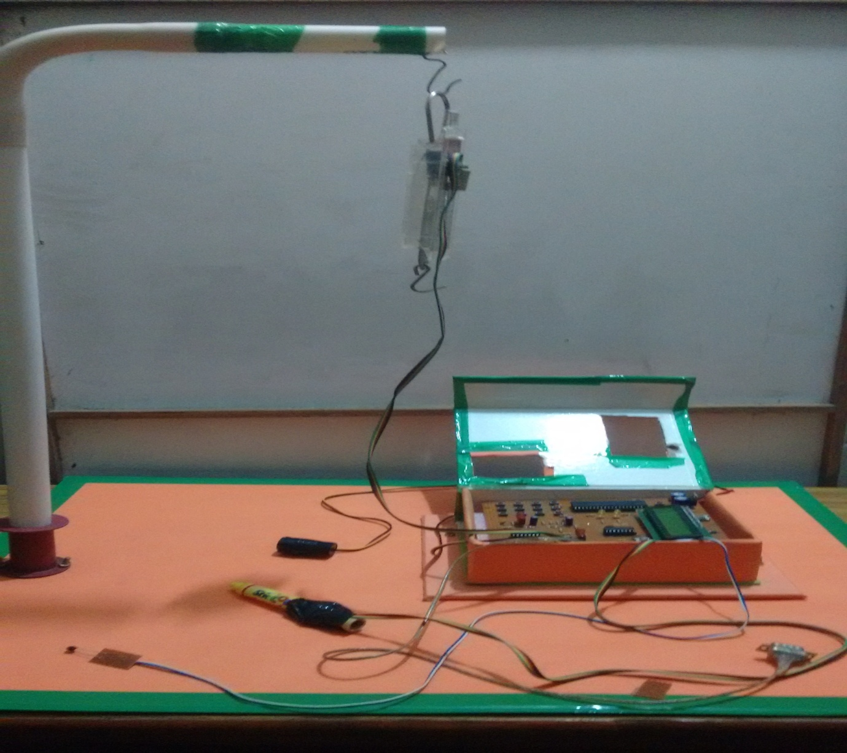

Project Image