**BIOMECHANICAL ENERGY BASED LAMP CUM CHARGER**

**THEME: Electrical and mechanical engineering**

**PROJECT ID: EE30**

1 **INTRODUCTION:**

1.1 PURPOSE:

1. To harvest biomechanical energy from human motion in order to offer a promising and clean alternative to electrical power supplied by batteries for helmet lamps and mobile electronic devices.
2. To develop an elbow brace for mine workers which generates electricity by utilizing elbow motion during mining and to use the generated electricity to power torch helmets.
3. To provide a knee-mounted brace equipped with contemporary electronic components that generates electricity from a person’s stepping action in order to charge mobile phones.

1.2 SCIENTIFIC PRINCIPLE INVOLVED:

The device harnesses the biomechanical energy from human provided by the to and fro motion of the elbow/knee. This motion of the elbow/knee is converted to rotational motion of a gear mechanism. A common axle connects the secondary gear with a stepper motor generator. As the gear system is put to a rotational motion, the device generates electricity on the principle of electromagnetic induction. The alternating current is converted into direct current by using diode (PN junction).

A stepper motor generator is an electromechanical device that uses the concept of stepper motor to divide a full rotation into discrete steps and converts mechanical energy to electrical energy.

2 **DESCRIPTION:**

2.1 MATERIALS USED:

1. Aluminum sheets (for the device frame)
2. Gear mechanism (for extending elbow/knee motion into rotational motion)
3. Alternating Current (AC) to Direct Current (DC) conversion circuit, having components:
   1. Two 470 µF capacitors (25V and 10V)
   2. 7805 regulator IC for regulated 5V power supply.
   3. Diode for unidirectional flow of current.
4. Multiple mobile pins
5. LED light and helmet
6. Stepper motor

2.2 WORKING METHODOLOGY:

The following steps describe the working of the device:

1. The biomechanical energy of man (which occurs in the form of kinetic energy of the elbow/knee of the user) is converted to rotational energy of the gear mechanism.
2. The gear mechanism comprises of a primary and a secondary gear connected with each other. The secondary gear (connected to the axle of alternator) has lesser teeth compared to the primary gear. This is done to increase the number of rotations per elbow motion/stepping action of the wearer (user). The rotational motion of the secondary gear is transferred to the stepper motor generator.
3. The stepper motor generator generates electricity based on the principle of electromagnetic induction (EMI).
4. The electricity as generated by the stepper motor generator is AC. This cannot be directly utilized by torch helmets or mobile phones (which require DC). The alternating current generated by the device needs to be converted into DC. This is done by employing a conversion circuit. The conversion circuit consists of diodes, resistors, 7805 regulator IC and two 470 µF capacitors (10V and 25V). The diode helps in unidirectional flow of the alternating current. The capacitors help in reducing ripples in the circuit and provide a uniform flow of current to the torch /mobile phone. The 7805 regulator provides a constant 5V supply to the external device. The diode forms the most important part of the conversion circuit. The conversion circuit diagram has been given at Diagram-1.

2.3 APPLICATIONS AND FUTURE SCOPE:

The device has a broad spectrum of applications:

* + 1. The device can be used to power cell phones, which form an integral part of modern life, during jogging and walking.
    2. The commercial design of the device can power prosthetic or artificial limbs. Thus, it is very useful for people who cannot walk.
    3. The elbow braces can be used by mine workers. The contraption generates electricity by using to and fro motion of the elbow. This electricity can be used to power torch helmets.
    4. It can power medical devices/implants viz, hearing aid etc as these devices have low current requirements.
    5. The device can also charge power banks. There are circumstances when even sources for charging power banks are unavailable. In such situations the device can act as a substitute.
    6. In this project, we have converted the generated AC to DC using necessary electronics. We can also keep the current in its original AC form if required. Thus, the device can power almost all appliances (be it AC or DC).
    7. These devices are of utmost utility in remote/rural regions where availability of electricity and its supply is poor.
    8. In combat situation, soldiers are always required to carry loads of power source (batteries) with them. The device can be of help as it can drive many small gadgets of soldiers.

2.4 COST AND TIME TAKEN:

Rs.900/- and 30 days.

3 **ILLUSTRATIONS**

3.1 CIRCUIT DIAGRAM:

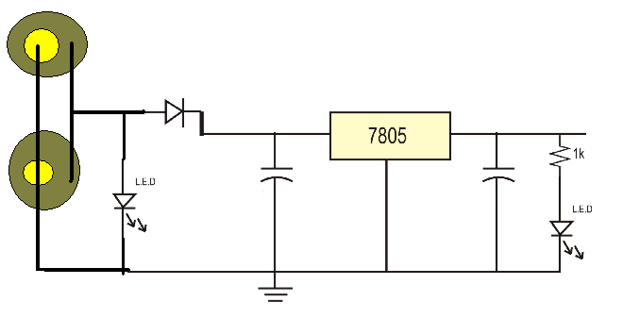

Conversion Circuit Diagram

3.2 PHOTOGRAPH OF EXHIBIT

